“Cask of Amontillado” Assignment 3
Coat of Arms:
Find out if your family has a coat of arms and draw a picture on poster board.

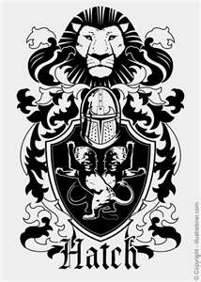
If your family doesn’t have one, you may design your own either on poster board.

